The results of the 10 questions asked in2106 SHPOA Members Survey are posted below. 411 members responded to the survey this past November, although not everyone answered every question.

Question 1 Rank your priorities of these projects from 1 to 7 (1 Being the highest).

Beach Management and Restoration | 1
10 year Borough Financial Plan including projected tax increases | 2
Borough Flood Prevention Program | 3
Bay and Basin maintenance including dredging | 4
Water Supply and Conservation Program | 5
Undergrounding Power Lines and Eliminating Metal Utility Poles | 6
New Police Station | 7

Question 2 Are you in favor of the Borough spending over $30,000,000 based on initial estimates to eliminate the metal utility poles? This amount represents burying the wires, not taking down the poles.

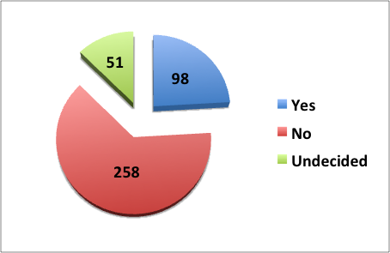

Question 3 In the past 12 months, have you read the Borough's budget?

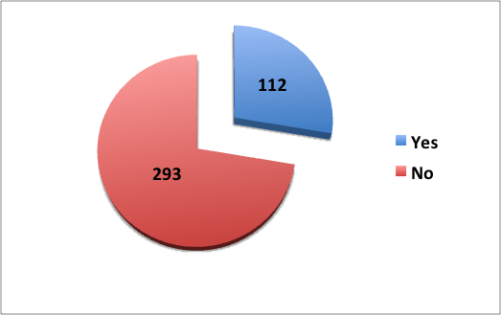

Question 4 In the past 12 months have you read the Borough's Annual Drinking Water Quality Report?

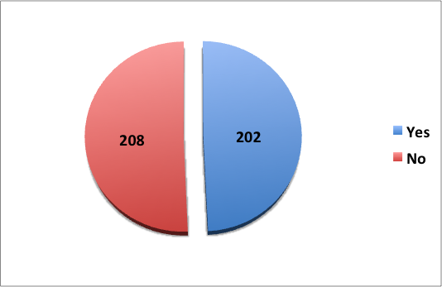

Question 5 How often do you visit the Borough's website?

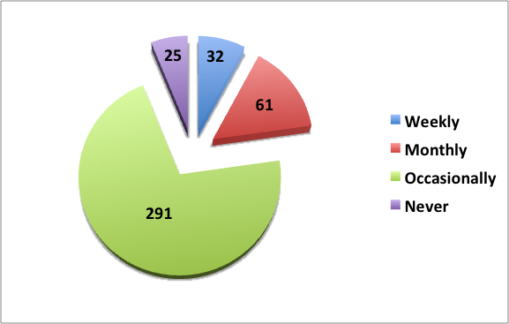

Question 6 Do you visit SHPOA Facebook page to stay informed regarding events and activities in Stone Harbor?

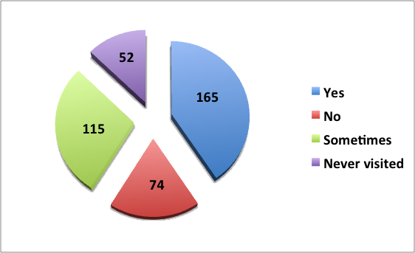

Question 7 Does the SHPOA website provide helpful information?

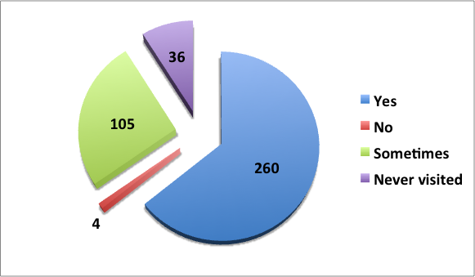

Question 8 Do you find the SHPOA email Blasts keep you informed?

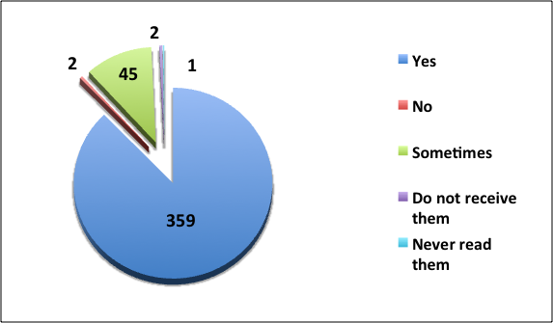
Question 9 What do you use to keep current about Stone Harbor? Rank each selection 1 thru 6 in order of preference.

SHPOA website | 1
Borough website | 2
Seven Mile Times website | 3
Cape May Herald website | 4
SHPOA Facebook | 5
Borough's Smart Phone App | 6

Question 10 Are you a year round resident of Stone Harbor?

